Bangkok July 2017 INVITATION

On behalf of the AITMA organizing committee. I take pleasure to invite all of you to this most beautiful Martial Arts event.

14th International Thai Martial Arts Festival and Congress.

To be held at world heritage city of Ayutthaya, Thailand. From 13th March to 20th March 2018

Celebrate Nai Khanom Tom day Wai-Kru Ceremony

Muaythai-Boran / Thai Massage / krabi-Krabong/ Referee

AITMA&IMTF world Title Fight

With price money and IMTF Belt for the winner

All Participants with Cerificate/Medal.

We are sure you that 14th AITMA Festival will provide an important opportunity to all martial arts sports persons to exchange their experiences. Techniques, new ideas and cherish long lasting friendship among each other.

We will do our best to provide you with a pleasant, memorable and enjoyable stay in Ayutthaya Province, Thailand.

Please find the details pertain to the festival enclosed below. Hearty welcome to Ayatthaya! Your in Thai Martial Arts. Dr. Channarong Suhongsa AITMA. Chairman with Respect and best Wisher AITMA Organizing Comity

**1. Event & Activities**

1.1) IMTF Pro/Pro-Am Class C Belts, Prizes, Certificate.

1.2) Celebration of Nai Khanom Tom Day and Wai-kru Muaythai.

The day of pay respect, and homage to Nai Khanom Tom, passed and present teachers, Acknowledgment of, New comer teachers, by present certificate and higher rank of Mongkon.

1.3) Seminer of Muay Boran and Krabi-Krabong by top grand Masters.

**2. Entries :**  Entry Form A (Entry by number) must reach to organizer by 2*0th January 2018.* PLEASE SEND ALL ENTRY FORMS TO: E:mail muayboran [2011@gmail.com](mailto:2011@gmail.com)

🞄 Entry Form B (Entry by Name) And Fight and Hotal Information Form must reach to organizer by 2*0th January 2018.*

2.1 “C” Class Championship Certificate, Gold Silver Bronze 3x2 Minute Rounds.

Male : 54kg,60kg,63.5kg,67kg,71kg,75kg,81kg,86kg,90kg+

Female : 45kg,48kg,51kg,54kg,57kg,60kg,63.5kg,67kg

2.2 Pro-Am Championship Belts Certificate 3x3 Minute Rounds.

Male : 60kg,63.5kg,67kg,71kg,75kg

Female : 45kg,48kg,51kg,57kg,60kg

2.3 IMTF Professional Championship Belts Prizes 2,000 THB, 5,000 THB 8,000 THB Certificate 3x3 Minute Rounds.

Male : 60kg,63.5kg,67kg,71kg

(Please send Photo,Age,Height,Weight and Eight record until by *20th January 2018.*)

**3.) Entries Fee:** (3 Days Course in Muay Boran & Krabi Krabong *14th - 16th March 2018.*)

The courses fee required is 125 EUR Per Adult and 50 EUR per junior per event paid at the registration desk before strating. The fee covers the cost of Transportation to & form the airport and includes the welcome party along with a participation certificate.

*Khan & Sash grade for students who register will be 1,000 THB each level.

* Kru Assessment & register Khan 10 - 13 Free Khan

*All Traditional Uniform and Mongkon’s must be worn for Wai Kru Cremony.

**4. Rules and Regulation:** The competition Rules and Regutatios will run in accordance with the following organizations AITMA.

**5. Accommodation:** For room Resservation Grand Hotel Ayutthaya.

|  |  |  |
| --- | --- | --- |
| Date | Time | Acticity |
| http://www.ayutthayagrandhotel.com/ | Single (1 bed) | 1,500.-Baht per Night |
| Twin room (2 beds) | 1,500.-Baht per Night |

(Including breakfast, service charge. vat & Tax)

The final plan will be show in Ayutthaya Grand Hotel On 16th March 2018 For Room Reservation: *Ayutthaya Grand Hotel* Double room incl. breakfast 1,500 Baht. with respect and best wishes AITMA Organizing Commity.

http://www.ayutthayagrandhotel.com/

**6. Prize :** Medal & Diploma will be Awarded to the 1th,2th, and 3th places in each class.

**7. Transportation service:** Shuttle bus will be arranged from Bangkok international airport to the official hotel and from the official hotel to the venue only for the participating delegates who are staying at the official hotel, please inform us about your fight schedule (arrival date, time and right number) and hotel reservation by 20th January 2018.

**8. VISA:** Please contact the Organize committee regarding any VISA requirements or apply for VISA form your own Embassy, Consulate or VISA office in your country.

**9. Flage / Authems:** Please bring audio – cassette tape or CD of your National Anthem and two National  *Flags (72 cm. x 120 cm.)*

**10. Referee:** We propose and welcome you to bring your referees.

Please send entry by Number. Before 20th January 2018.

**11. Participants:** (Including Officials-Athltes &Guests) : There is a registration fee 1,000 THB. The fee cones the cost of Tramsportation to a form the airport and includes the welcome party along and a participation certificate for Athletes.

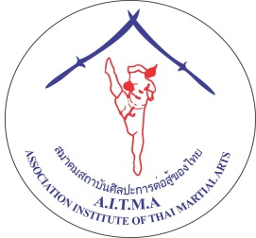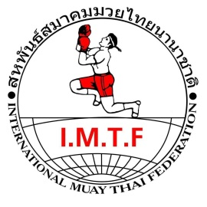

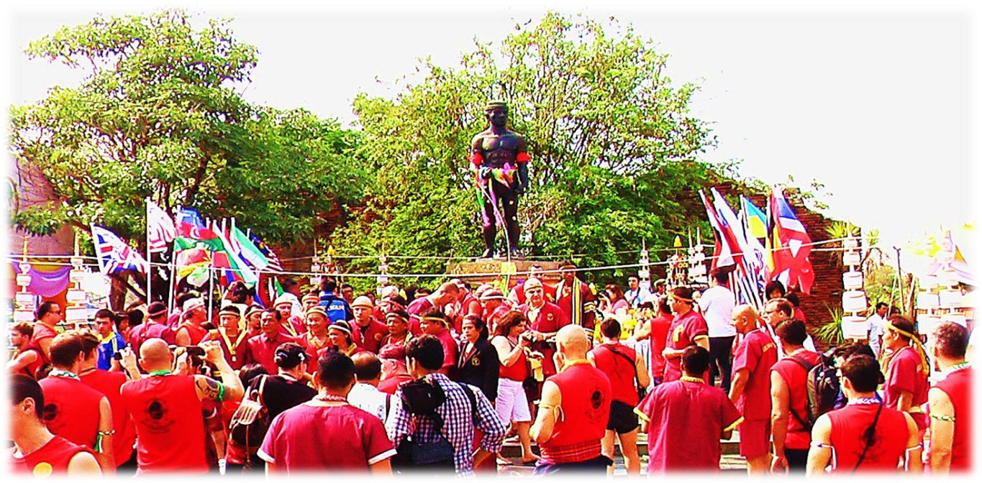A WORLD HERITAGE SITE CITY OF AYUTTHAYA

PRESENTS

14th World Thai Martial Arts Festival

CELEMRATION NAI KHANOM TOM DAY

ASSOCIATION INSTITUTE OF THAI

MARTIAL ARTS

Wai-Kru Ceremony

Muaythai/Boran & krabi Krabong Seminar

AITMA&IMTF Pro/AM Championship Belt

IMTF World Title Fight

Date 13th – 20th March 2018

Venue: City of Ayutthaya Stadium, Ayutthaya, Thailand

[www.aitmathai.com](http://www.aitmathai.com) www.imtf-thailand.com

Email: [muayboran2011@gmail.com](mailto:muayboran2011@gmail.com) , ,Facebook : Muayboran Shongsa

Moblie: (668) 0561 4798

PROGRAM OF ACTIVITIES 14th International Thai Martial Arts Festival and Congress.

|  |  |  |
| --- | --- | --- |
| Date | Time | Activity |
| 13th March 18 | 08 : 00 | Final Arrival of ALL Teams & Partcipants. |
| 14-15th March 18 | 07 : 00  09 : 00  14 : 00  16 : 00 | Early rise on bus to temple ground. For meditation,  traditional traning in Muayboran and Krabee-Krabong.  Back to hotel for breakfast Muayboran and Krabee-Krabong courses |
| 16th March 18 | 07 : 00  13 : 00 | Early rise on bus to temple ground.  For meditation, traditional traning in Muayboran and Krabee-Krabong. Back to hotel for breakfast Grading Examination for Khan Mongkol |
| 17th March 18 | 06 : 00  13 : 00  -  15 : 00 | PAY HOMAGE TO NAI KHANOM TOM CEREMONY.  WEI-KRU CEREMONY starts by arrival of the chairman.  ALL THE ATHLETES AND OFFICIALS IN TRADTIONAL UNIFORM.  Introduction to all the Grand Masters  And Masters all.  Ranking of Kru. Oath of respect to all teachers.  Present Mongkon and blessing to the new comers.  All the participant entry and line up to countries Wai-Kru Ceremony.  Welcome Dinner Party by Tourism Authority of Thailand. |
| 18th March 18 | 06.00  10.00  12.00  -  18.00 | Weight In.  Official Draw. (Hotel).  Lunch.  AITMA Official Meeting, Separate of all  Sport and subject of competition.  Start Qualify Pro/Pro – AM/Class C |
| 19 - 20th March 18 | 06.00  18.00 | Weight In.  Start Qualify Pro/Pro – AM/Class C |
| 21th March 18 | 08.00  -  09.30 | Breakfast and Check out  Travel bank to Bangkok  Or Holidays Places. |

* The Grand Master conducting the Traditional Muay Boran & Krabi Krabong Courses along with khan grading for students who register for them are: -

* The organizer has the right to modify the schedule depending on the number of entries.